MED D - Drug Pricing Tool

MED D - Drug Pricing Tool
Using the Drug Pricing Tool
Related Documents

Description: This document provides guidance to the CCR on how to access and use the Drug Pricing Tool.

Does not apply to BlueMedicareRx (NEJE)

Using the Drug Pricing Tool

In order to utilize the Drug Pricing Tool, the CCR will:
Step | Action
1 | Access site online at: https://enroll.aetnamedicare.com/s/shopping-tools/rx-drugs?PlanYear=2026&step=ZipCodeFallback.
2 | Enter the Zip Code and then click Next.  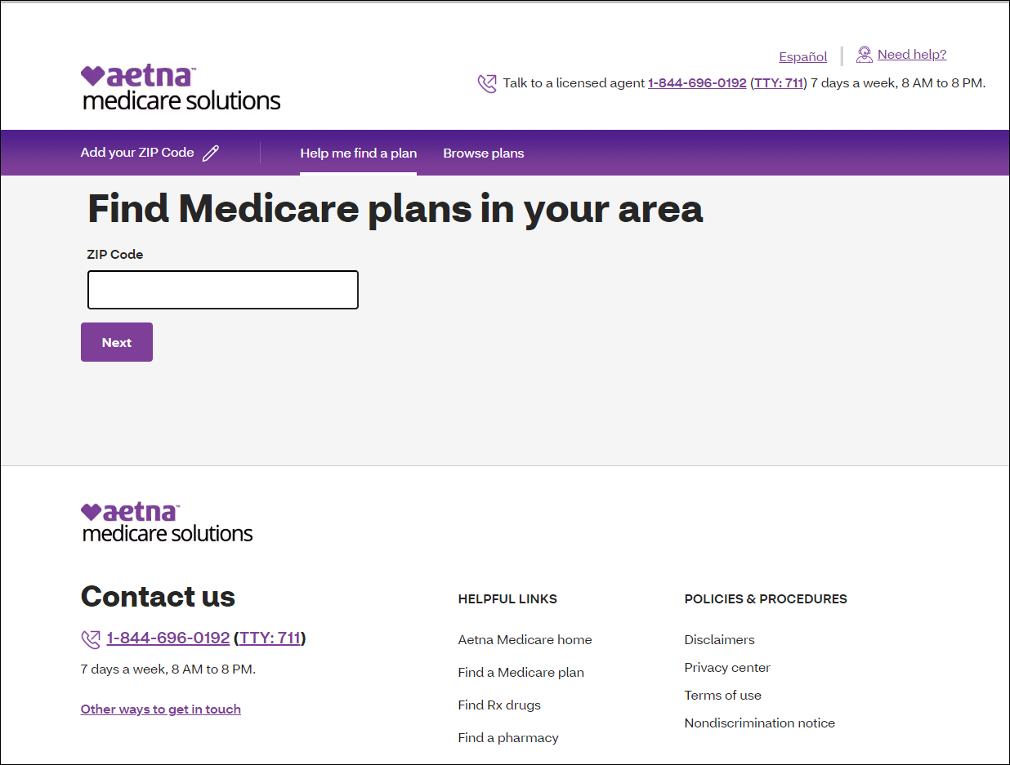
3 | Select the beneficiary’s Medicare Plan and then click Next.  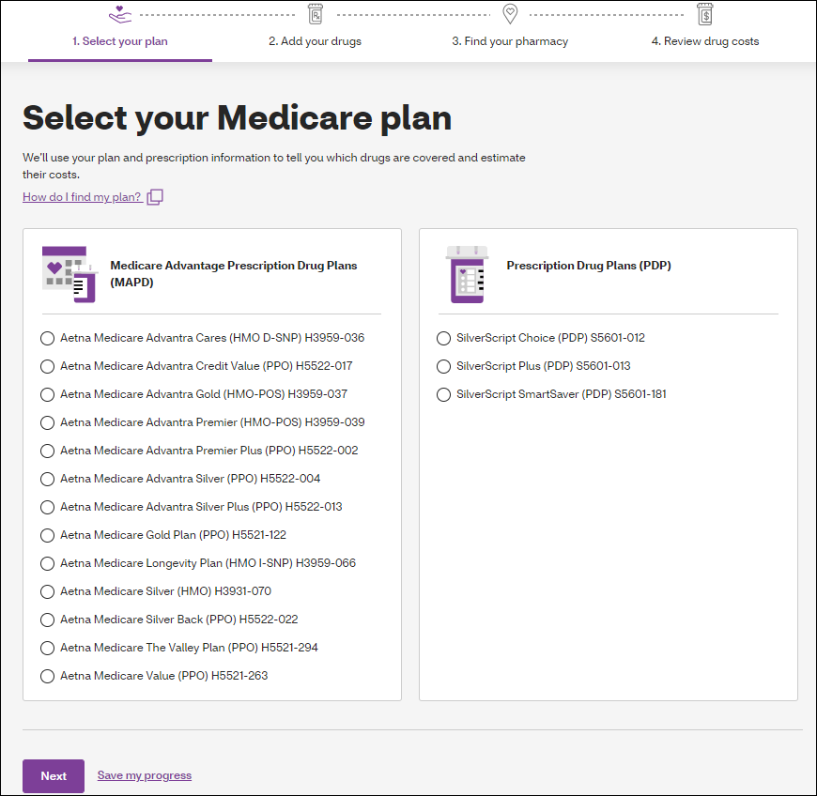
4 | Complete the following information and then select Add drug.  - Dosage and form  - Quantity and frequency  Strength, Dose and quantity per month frequency MUST be CONFIRMED with the beneficiary.  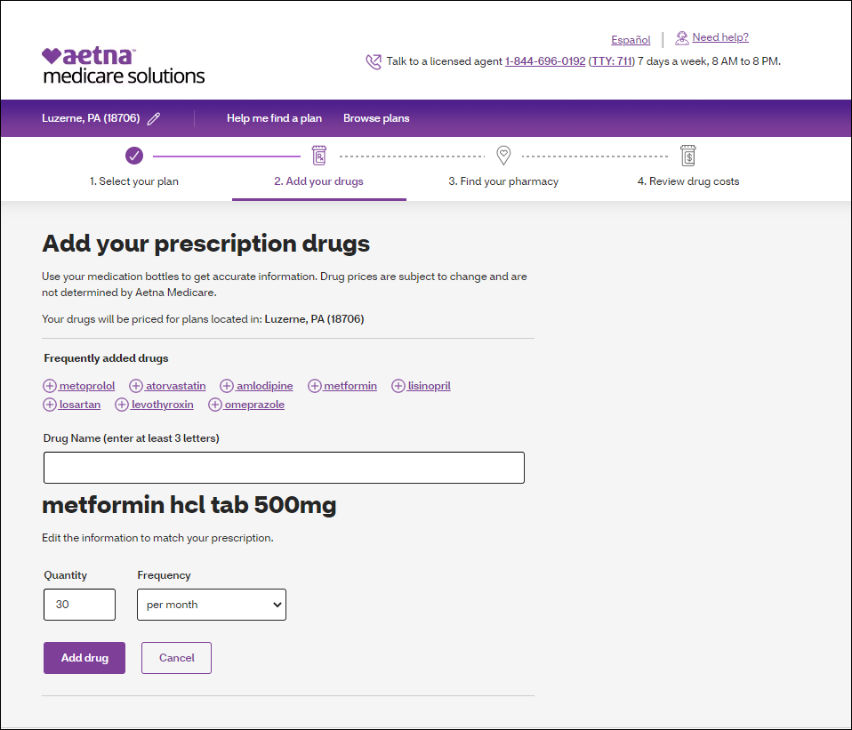  Result: Drug will be added to Your Presciptions list.
5 | Repeat Steps 3-4 until beneficiary’s prescriptions list is complete and select Next.
6 | Choose the beneficiary’s pharmacy by clicking the box for the appropriate pharmacy and then select Next at the bottom of the page.  As many plans have Preferred and Standard pharmacies, this step will impact the pricing that the beneficiary sees.  - The pharmacies that are displayed are based on the ZIP code the beneficiary has given you.  Notes:  - For more pharmacy choices, select the page links at the bottom of the search results.  - To search a different area for a pharmacy, enter a new zip code.  - To search for a specific pharmacy (Example: CVS), enter the pharmacy in the pharmacy name field.  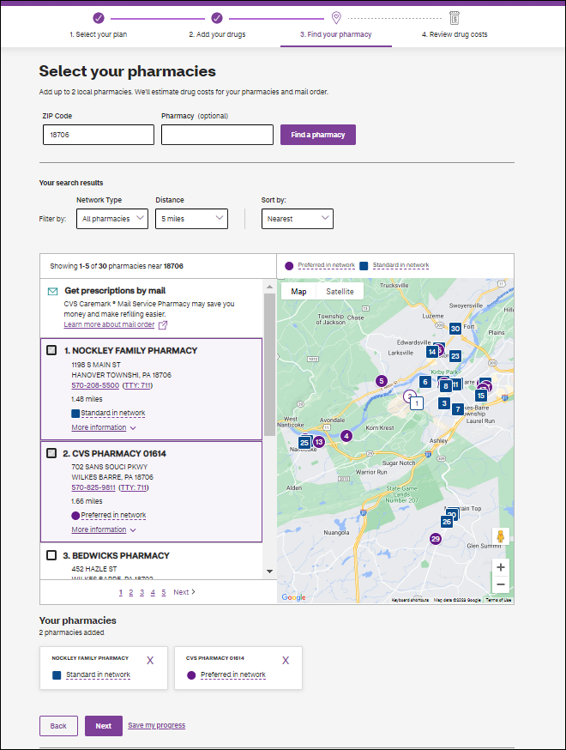
7 | Provide the beneficiary with specific drug pricing information.  Disclaimer:  Please note the prices quoted are estimates and may not reflect your actual out of pocket costs.  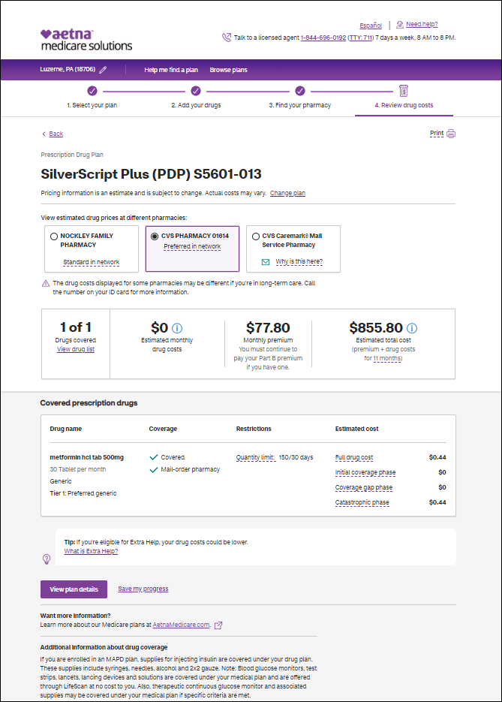

Top of the Document

Related Documents
Parent SOP: CALL-0048: Medicare Part D Customer Care Call Center Requirements-CVS Caremark Part D Services, L.L.C.
Abbreviations/Definitions: Abbreviations / Definitions

Top of the Document
Not to Be Reproduced or Disclosed to Others without Prior Written Approval
ELECTRONIC DATA = OFFICIAL VERSION - PAPER COPY = INFORMATIONAL ONLY

